## Senior Seminar Case Study Analysis: Revamping the Curry College Application

May 3, 2021

[GitHub link](https://github.com/Chris4mny/curry_App)

## Project and Summary of Project

For this semester, our class created a prototype for a new application for curry college. Since the current curry app was rendered unusable, our job was to create a working prototype of a new application. To complete the task, we were required to conduct a survey to find out which features to include, design and program the prototype, and finally test it out.

## Written Assessment of the Current Curry App

Overall, the app is unintuitive, making it difficult to recommend to students. The only pro of the current myCurry app is that it is available for download on iOS and Android, making it available to all students with smartphones. Unfortunately, the app is not designed well, which makes it not user-friendly. The text is in front of a busy background which makes it hard to read. The buttons link to pages that do not load and if they do the information is not useful or organized well. For example, the events section page takes a while to load, and when it does, nothing appears. Also, there is no link to Canvas which Curry uses as their learning management system. Instead, there is a button that links to BBLearn that is not on the Apple app store. Other pages that are not user-friendly are the Facebook, Twitter, and photo section. When the user taps one of these buttons you are taken to an in app browser instead of the default browser on iOS. Also the Maps page displays its own interactive map instead of re-directing you to a navigation app like Google Maps or Apple Maps. This does not allow the user to easily navigate to Curry College. Instead they have to go into their own mapping app and search for Curry College. Because the myCurry app has a poor user experience, we decided not to use it as a baseline.

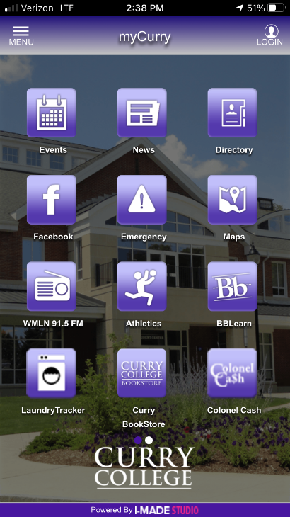

## Benefits to Revamping the Current App

With a working curry application, there can be several benefits. With the new app, Curry students will now have access to information that is accessible wherever they are.

## Application SWOT Analysis

|  |  |
| --- | --- |
| SWOT Analysis | |
| Strengths | Weaknesses |
| * The app gives the user on-the-go information * Easy to navigate * Quick access to relevant and updated information | * Limited timespan * Communication |
| Opportunities   * Learning new programming languages * Introducing a working Curry App * Having a go-to hub for everything Curry * Retention and recruitment | Threats   * Third-party developers * Strict design standards |

## Timeline for Implementation

April 18

Application starts being tested

March 29

March 23

March 18

February 26

Development team starts creating app

Prototype of app is completed by design team

Survey is closed and results are gathered

Survey is distributed to all Curry College students

## Survey Analysis

The mission statement was completed with students from the senior seminar IT class in order to figure out the steps and purpose of the case study. The mission statement that everyone came up with was to create a better experience for the students who use the current myCurry app. The steps following the mission statement are to provide Curry students a mobile interface to find a retrieve data through having usable tools and features in the myCurry app. The second step of the mission statement is to find what students want on their app through creating a survey.

**Mission Statement**: To create a better experience for students who use the current myCurry app.

**Step 1**: Why does this exist: To provide Curry College students with a mobile interface to find

and retrieve data.

* + What will be beneficial for students to have access to in the myCurry app
  + In the previous app, there were too many features that students did not find necessary
  + For the new myCurry app, the list of usable tools or features will be narrowed down

**Step 2**: Data that students want to find: Find out what audience wants (Curry Students)

* + How to find what audience wants: Survey
  + **Overall goal**: Provide mobile access point for Curry information app

**Goals**:

During the preparation of the survey, the survey team had to consider the mission statement and steps taken for this case study. The mission statement was to make a more user-friendly myCurry app available on smartphones. This case study aimed to provide Curry College students with a mobile interface to find and retrieve information. Thus, the factors that must be considered for the survey team when creating the survey were: What the students want in the app and trimming the list of usable tools down.

The second step of this case study was to create a survey in order to understand what Curry students would find useful in the myCurry app. Before creating the survey, the team first listed the goals for the myCurry app. The goals were:

* Understand students’ experience with the myCurry Website
* Understanding and meeting the students’ needs by gathering information through a survey
* Make students feel that they are valued with this new application

The goals that have been create was for the Survey Team to get a better understanding of how to go

about the case study and to think about the students’ needs as we begin to create the survey.

After listing the goals, the survey team created a rough draft of the survey questions to show to the senior seminar IT class. The first draft of the survey consisted of questions such as:

* What is the main feature you would like to see on the app?
* Do you have any past experience with the old Curry app?
* Which application on the Curry website do you use the most?
* Which application did you have a negative experience with? Why?
* Is there an application on the Curry Website that should be improved?
* Did you face any issues with the Curry Website’s applications? If so, which one?
* What is the difference in your experience between application X and application Y?
* What can the Survey Team provide in this application that can help and benefit you?
* If you had a magic wand, what would you change on any of the Curry Website applications?
* Tell me your daily experience with the Curry’s Website?
* Do you think any of Curry Websites’ apps are important? If so, which applications are relevant?
* Any irrelevant applications?
* What applications do you use on a regular basis?
* Is there anything you would like to mention?

After creating the first draft of the survey, the survey team had two meetings, one meeting with the survey team and the second meeting with the Senior Seminar Information Technology class, to see if the questions on the survey needed to be revised. The meetings helped the survey team figure out how to format the survey and modify certain changes to make it shorter and more straightforward for students to answer the questions. The survey team planned a meeting with Professor Gordon and Professor Gallant to review and check everything with the final draft of the survey and discuss how to distribute the survey to Curry students.

**Final Draft of the Survey for the Launch:**

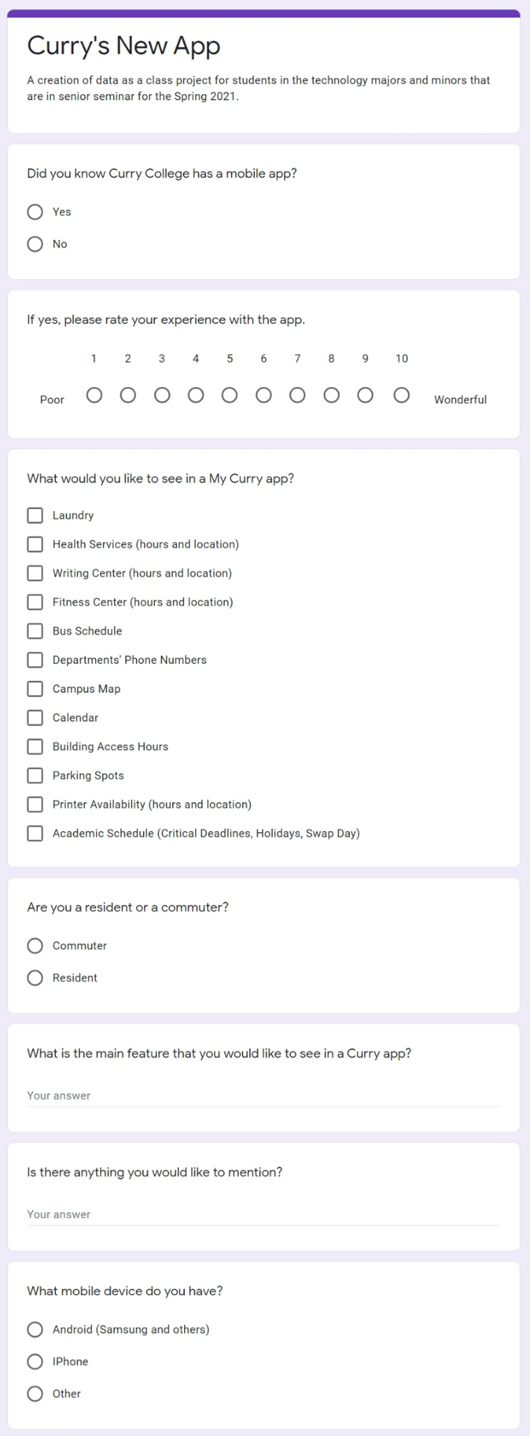

**Launch and assessment of survey**

The survey team had a meeting with Professor Gordon and Professor Gallant to review and check everything with the final draft of the survey and to discuss how-to distribution the survey to Curry students. The survey team mentioned sharing the survey with faculty and professors of Curry for them to share it with their students. Both the team and Professor Gordon and Gallant created a list of professors to share the survey with. Within the meeting, Professor Gordon and Professor Gallant mentioned talking to Tina Gaynor and the AAs about them having the list of students for certain majors and how they can have work-study students copy and paste the link. In addition, the survey team discussed the plan of distribution to the senior seminar IT class to get a better insight on other ways to distribute the survey. After discussing with the students from the senior seminar IT class, we all agreed to reach out to David Hajjar from the tech center to distribute the survey. Mr. Hajjar agreed to distribute the survey and sent it out to Curry students, as seen below.

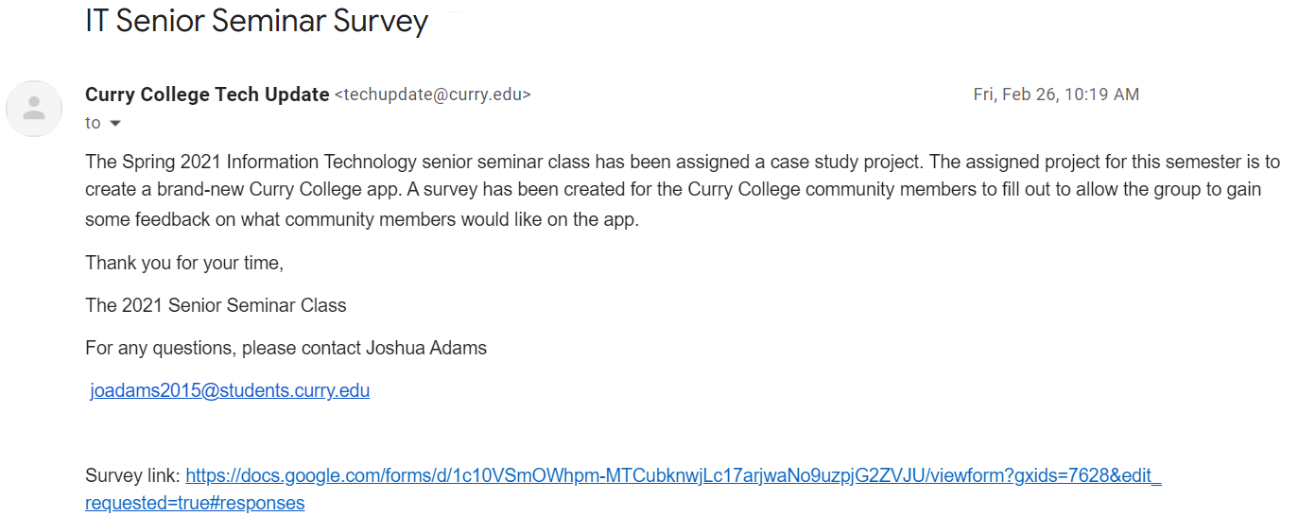

**Written summary of survey results**

After gaining 105 responses from the survey, the survey team analyzed the responses and took note of the results. The most important features that the students want for the myCurry app were laundry and academic schedule. However, the survey team had to consider that laundry is a separate website, and it would take more time to work on it. Other factors that the students wanted were to have a better User Interface (UI) and layout of the app. The survey team discussed the results with the senior seminar IT class and concluded that we should incorporate the top five picks that students want for the myCurry app. The tops five picks were:

1. Academic Schedule - 90 Votes
2. Writing Center Hours / Location - 76 Votes
3. Departments’ Phone #s - 74 Votes
4. Bus Schedule - 71 votes
5. Parking Spots - 71 Votes

## Development of Application

1. Gather feedback from the target population on what is desired/needed
   1. In order to gather information from our target audience, we created a survey that was distributed to the students of Curry College. Overwhelmingly, the top choice from the student body was laundry tracking. Due to time constraints, the development team was unable to implement the laundry tracking and instead planned to integrate the students’ next top choices, which included various schedules.
2. Create a list of requirements and features
   1. The list of requirements and features can be found below.
3. Determine what programming environment would best suit our needs
   1. We plan to develop this app using Flutter, which is a UI toolkit created by Google. Our development team had also considered using Xamarin, which is a mobile application development framework. Ultimately, the development team did not work with Xamarin because many developers experienced numerous issues when using the Xamarin development environment in the past. We plan to work off of the wireframe that is below.
4. Test the application with the target population
   1. The testing team will test each aspect of the application to ensure that the application meets their requirements.

**Requirements and Features**

Requirements:

* Display writing center hours
* Display bus schedule
* Display department phone numbers
* Display academic schedule
* Display parking lot information

Features:

* Store static PDF documents to be displayed

**Application Wireframe**

Challenges & Approach:

1. Eliminate barriers to entry on application startup
2. Design a cohesive interface for familiar and unfamiliar students
3. Create a minimalistic UI while keeping students wants as a focus
4. Provide a seamless and linear user experience.

In this project, we took a goal-oriented design approach that proved to be quite successful in our design efforts. We found qualitative research methods to be the most useful, consisting of a survey with students of Curry College, literature review, competitive analysis, and most importantly, our persona hypothesis construction.

**Sketch of Application Navigation**

We constructed a user flow of what a basic start to finish journey looks like while navigating different sectors of the application prototype. This helps us understand how users can interact with the app and see navigation through user goals. After sketching out some p&p wireframes and thinking through the preliminary flow, we reviewed what was necessary, unnecessary, and what areas needed improvement. We spent a lot of our time on this step to make sure we had the finishing touches on the underlying UX before moving onto the visuals.

**Programming the Application**

The development team merged both the front-end and back-end teams to ensure that the application would be consistent. To start off, the front end and back teams focused on creating requirements and featured for the application. Both teams decided to split up what we should put in the back-end of the application as well as the framework of the application itself. The requirements and features served as a “to do” list of what we needed to program in the app and what features it will have. Once we received the design from the design group, the front-end and back-end teams started their work.

As previously stated, this app was created using Flutter. Before the back-end created the app, each member within the development team downloaded the necessary framework to begin familiarizing themself with this new environment. When programming the application, our team ran into some difficulties in regard to implementing the exact wireframe that was previously approved. For example, we were not able to implement the icons that are seen on the homepage and on the bottom menu. Instead, we mimicked this as best as we could with a hamburger menu. We were successfully able to match the color scheme and the implementation of static PDF taken from the myCurry portal.

Our group chose Flutter as they have great resources on Flutter's website ([Flutter.dev](https://flutter.dev/)), including many videos and instructional pages. Flutter also provides easy deployability to iOS and the Android store when the app is ready to be published. When you install the Flutter program by following the instructions on [Flutter.dev](https://flutter.dev/), it provides you with all of the packages for iOS and Android. This is one of the many benefits of using Flutter. Flutter also gives the user commented stubs on where to start and even provides you with example code, a background color, and a button with a click event that displays a counter. The implementation process for downloading Flutter is laid out step by step on the website and must be followed for success. If you are using VS Code as your IDE, you will need to install the Flutter extension and the Dart extension.

**Future Maintenance**

This application will primarily be updated by the Tech Center on campus, but may also be updated by future students of Senior Seminar: This is IT! In order to update this application to accommodate new PDFs the two main files the developer must work with are “main.dart” located in the lib folder within the application and “pubspec.yaml” located in the main folder within the application.

Additionally, this app is iOS and Android friendly. To further test this application in Android, the developer must use Android Studio which is a free downloadable software available on Mac and PC. Due to the limitations Apple sets when testing their products, this app may either be tested using XCode on a Mac or by using XCode within a virtual machine on a PC.

## Testing on Target Population

The target population is students for Curry College. The testing team was unable to get the application running, so all of our observations are based on a video demonstration of the application running successfully.

**Written Summary of Testing Results**

The front-end team had trouble running the application. The testing team was not able to get the application running up either. The testing team did observe and critique a video the back-end team sent. We all concluded that there could be more work done on the spacing of the home page. The testing team could not determine if you are able to zoom in on the PDFs that pop up when clicking on the buttons for the home page.

The testing team also were confused on the function of the purple button at the center of the arrow buttons. The color and location make it unclear that this button is a home button. Additionally, it seems that it would be possible to accidentally press the button when trying to zoom on the PDFs. The size of the text was significantly small and hard to read.

The Back-end end team did not have enough time to develop a fully functional UI and they tried their best to replicate the wireframe the design team designed. They also notified the testing team that they faced many technical issues during the development process

**Limitations of Testing**

Due to limitations of time and technical issues, our team could not deploy a full functional Curry College application to the student body.

**Revisions to Application Based on Testing Results**

Based on the video of the application running, the testing team recommends revising the application to split up some of the larger PDFs into individual pages. This would make it easier to read the content and reduce the amount of zooming that is necessary. The content navigator should have an option for zooming and possibly increasing the size of text, disconnected to the content.

After displaying the application on an android phone, the testing team recommends revising the movement of the PDFs. When the user zooms in on any PDF, they are able to move the PDF behind the navigation buttons. When a user zooms into one of the PDFs, the PDF picture should not go past the navigation bar. The testing team also found out that every time a navigation button is clicked, for a split second you can see the home screen appear then disappear. When a navigation button is clicked, it needs to have a smooth transition without delay. There is also no way to get back to the home screen after clicking on any of the navigation buttons. The testing team recommends there should be a button back to the home screen. There should be an option to download each PDF, so the user does not always have to open the app to view them.

**Summary of process and findings**

The first steps the testing team took was getting the program files installed and installing Flutter onto our PC or Mac devices. Some of the team members experienced technical issues when installing Flutter. One member of the team, unfortunately, corrupted his OS when installing Flutter and had to transition over to a different PC. After successfully installing both the program files and Flutter, the next step was to get the UI running successfully. As the team tried to run the UI, they could not proceed due to a variety of error messages.

After some extensive research, the team found that they needed to install extensions which should help with successfully running the UI. Once the proper extensions were installed, the team tried to run the program and they encountered the same error messages as before. After having these technical issues, the team reached out to members of the back-end team for assistance. The team was able to get in contact with a few members, but they were unable to meet via Zoom. With none of the members available, one member from the back-end team was able to send over a video navigating through the UI that they developed. Since the testing team could not run the UI, they had to use the video in order to perform their testing analysis. After watching the video multiple times, the testing team found a few features that need to be implemented to the UI that could be an improvement. Overall, the testing team has concluded that the back-end team did a great job creating UI in such a short amount of time. With more time, the team believes that the back-end team could have fixed the bugs and the technical issues that they faced during the developmental process.